Chapter 17, Solution 71.

The schematic is shown below. In the Transient dialog box, we set Print Step = 0.02 s, Final Step = 12 s, Center Frequency = 0.5, Output Vars = V(1) and V(2), and click enable Fourier. After simulation, we compare the output and output waveforms as shown. The output includes the following Fourier components.

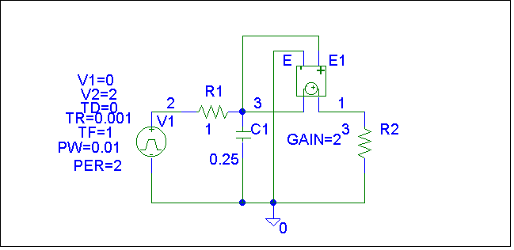
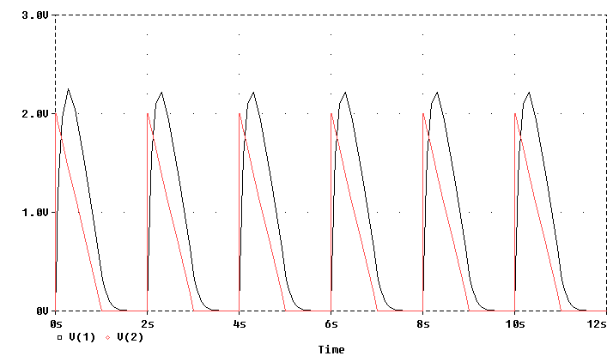

FOURIER COMPONENTS OF TRANSIENT RESPONSE V(1)

DC COMPONENT = 7.658051E-01

HARMONIC FREQUENCY FOURIER NORMALIZED PHASE NORMALIZED
NO (HZ) COMPONENT COMPONENT (DEG) PHASE (DEG)

1 5.000E-01 1.070E+00 1.000E+00 1.004E+01 0.000E+00
2 1.000E+00 3.758E-01 3.512E-01 -3.924E+01 -4.928E+01
3 1.500E+00 2.111E-01 1.973E-01 -3.985E+01 -4.990E+01
4 2.000E+00 1.247E-01 1.166E-01 -5.870E+01 -6.874E+01
5 2.500E+00 8.538E-02 7.980E-02 -5.680E+01 -6.685E+01
6 3.000E+00 6.139E-02 5.738E-02 -6.563E+01 -7.567E+01
7 3.500E+00 4.743E-02 4.433E-02 -6.520E+01 -7.524E+01
8 4.000E+00 3.711E-02 3.469E-02 -7.222E+01 -8.226E+01
9 4.500E+00 2.997E-02 2.802E-02 -7.088E+01 -8.092E+01

TOTAL HARMONIC DISTORTION = 4.352895E+01 PERCENT

